Redox Reaction of Potassium Ferrocyanide with Ascorbic Acid
Experiment by Hung, Salter, Kahn, Gindt. Layfette College
Adapted for Physical Lab (Chem 3934)
by Troy Loeffler, Louisiana State University
Introduction:
The purpose of this experiment is to give the student practical hands on experience using electrochemistry and spectroscopic techniques to monitor chemical reactions. At most colleges, chemistry students learn about electrochemistry very early on in freshmen courses, but most students never get to observe electrochemistry until an advanced analytical course. This experiment was designed to help alleviate this problem.¹
In this experiment the student will be using traditional electrochemistry techniques to study the oxidation-reduction reaction of potassium ferrocyanide and ascorbic acid. The ferrocyande ion in solution produces a bright yellow color which is easily measured by UV/Vis. In this reaction the ferrocyande ion undergoes a redox reaction to produce the ferricyanide, which unlike ferrocyanide, does not absorb in the visible region.
The core equation that is used in electrochemistry is the famous Nernst equation. When written out for this reaction the equation takes the form:
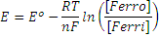
In a typical electrochemistry experiment the cell potentials of the reaction are unknown so it is necessary to calculate the concentration through other means. Fortunately, the two compounds absorb at very different wave lengths in the UV/Vis spectrum so it is possible to use the absorbance to determine the concentration at the various steps in the experiment. This of course takes advantage of Beer’s law:
Where is the molar absorptivity, l is the length of the cell used, and c is the concentration of the sample.

Equipment:
For this experiment you will be using the Ocean Optics Red Tide photospectrometer. This is a small compact UV/Vis that produces fast real time spectra with a good degree of accuracy.
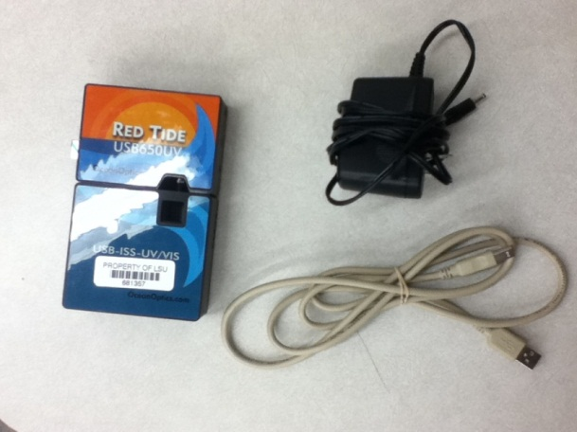
Fig 1.1 Red tide UV/Vis spectrometer and cables.
Safety:
Ferrocyanide is generally safe to work with so long as proper precautions are taken. Do not ingest and wear proper eyewear. It is important that you DO NOT MIX WITH STRONG ACIDS as this can release toxic HCN gas.
Setting up and Running the Red Tide Photospectrometer:
To begin your experiment, you must first properly connect the UV/Vis Spectrometer. To do this, attach the power and USB cables to the photospectrometer and proceed to connect the USB cable to the computer. After connecting the cables, start up the computer till you see the desktop screen. At the desktop look for a program called Logger Pro and open it.
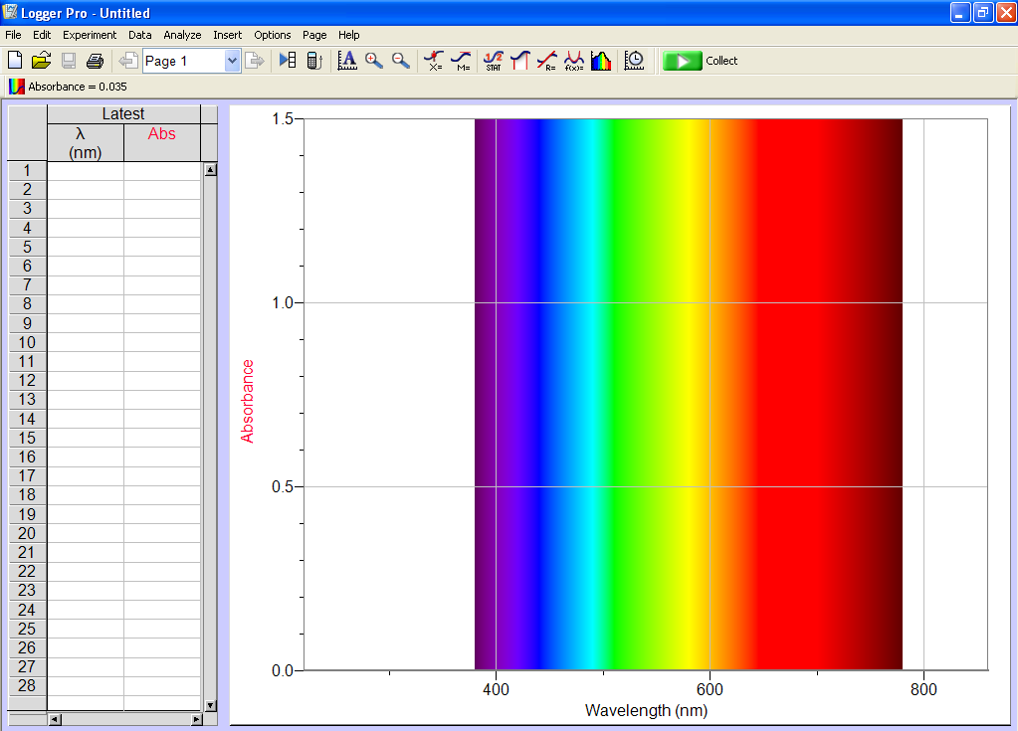
Fig 1.2 Main User Interface
BEFORE SCANNING A SAMPLE you must use a blank to ensure your data is accurate. Fill the cuvette you will be using in your experiment with your solvent (In this case water) and place it into the slot in the UV/Vis. With Logger Pro open, go to the tab Experiment > Calibrate > Spectrometer:1. The lamp will take 60 seconds to warm up. After the lamp is done warming up, press the “Finish Calibration” button to complete the calibration and then “OK” to exit. Next set change the units from % transmittance to absorbance by clicking on the tab Experiment > Change Units > Spectrometer :1 > Absorbance. Lastly click on Experiment > Set up Sensors > Spectrometer: 1. At this new interface set the “Samples to Average” to 50. You can use a different number of samples to average, but keep in mind while a lower number will produce faster results they will be more prone to electronic noise and the error associated with the noise.
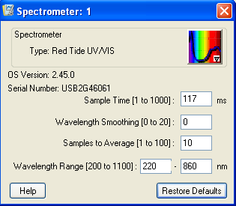
Fig 1.3 “Set up Sensor” Window
The device is now ready to take a spectrum. When you are ready, load the sample into the UV/Vis and click the green “Collect” button at the top right side of the user interface. After obtaining data press the red “Stop” button in the top right where the “Collect” button use to be. When performing multiple runs the computer will ask you if you wish to overwrite the previous data set. Select “Store Latest Run” to record multiple data sets.

Procedure:
Take 30mL of the 0.55 mM K₃Fe(CN)₆ stock solution and place it into a 100mL beaker. Attach the Ag/AgCl reference electrode and platinum electrode to the voltmeter. Suspend the electrodes such that the tips are completely submerged in the solution, but ensure that the electrodes to not touch the bottle of the beaker since this can cause errant results. After letting the voltmeter stabilize, record the initial volt reading.
Place an aliquot of the K₃Fe(CN)₆ solution into a UV/Vis cuvette and insert it into the spectrometer. Take a reading of the initial absorbance of the solution and return the aliquot to the 100mL beaker. When you have all your initial readings recorded, take a 5 μL aliquot of the 0.060 M ascorbic acid solution to the beaker. Let the solution stir for 2 minutes. Once the solution has equilibrated, record the new voltage and take another UV/Vis measurement. Repeat this step 14-20 times making sure to always return the solution used in the UV/Vis back to the beaker after each measurement.
Calculations:
Use Beer’s law to calculate concentrations at each step of the titration. Use your initial concentration to calculate the molar absorptivity constant ε. It should agree with the literature constant of 1.02x10³ L mol⁻¹ cm⁻¹. Using the concentrations and the potentials, create a plot using the Nernst equation to determine the standard cell potential and number of electrons transferred. In order to plot this you will need to use a mass balance equation for the ferro and ferri ions.
From the slope and the intercept of the Nernst Equation, calculate the number of electrons transferred and the E⁰ of the reaction. Perform the proper error calculations including the error generated by the linear regression.

Works Cited
¹Hung, Salter, Kahn, Gindt. "Redox Titration of Ferricanide to Ferrocyanide with Ascorbic Acid." Journal of Chemical Education (2007): Vol. 84 No.9 1461-1463.

