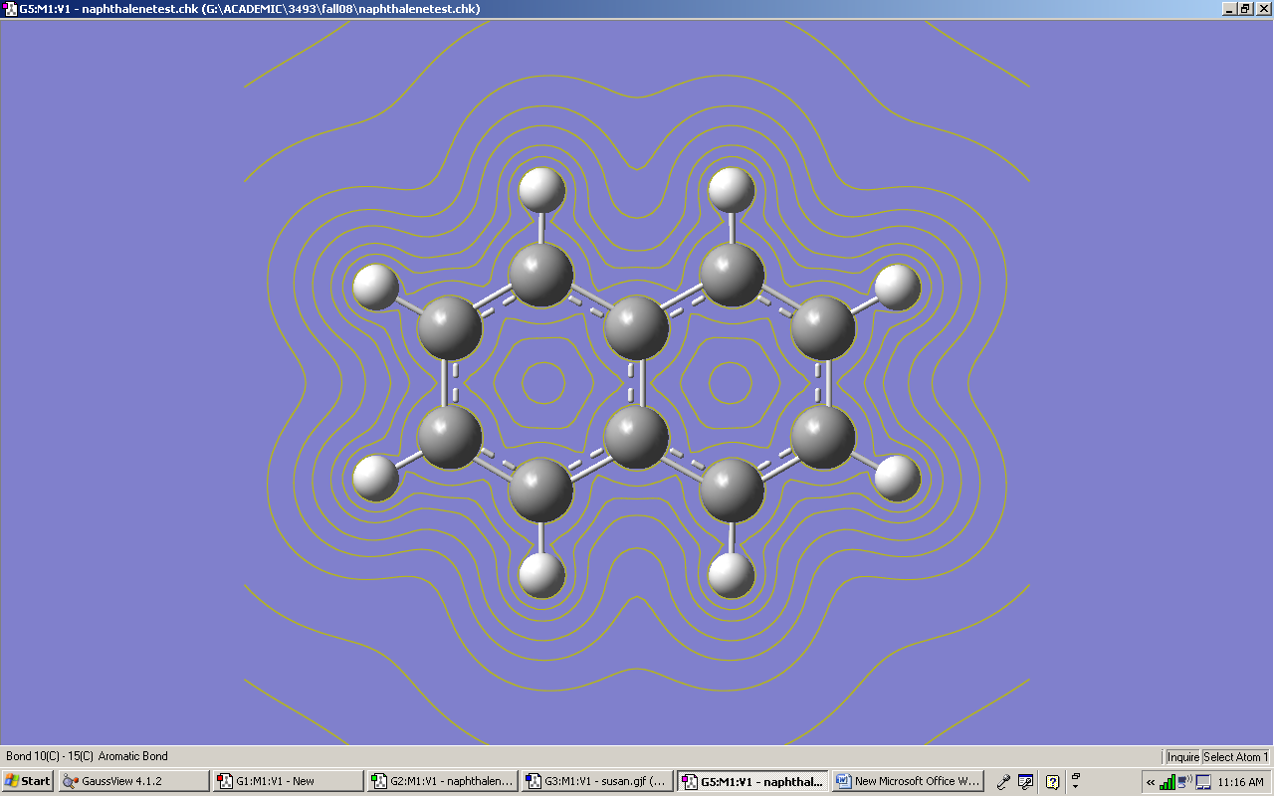

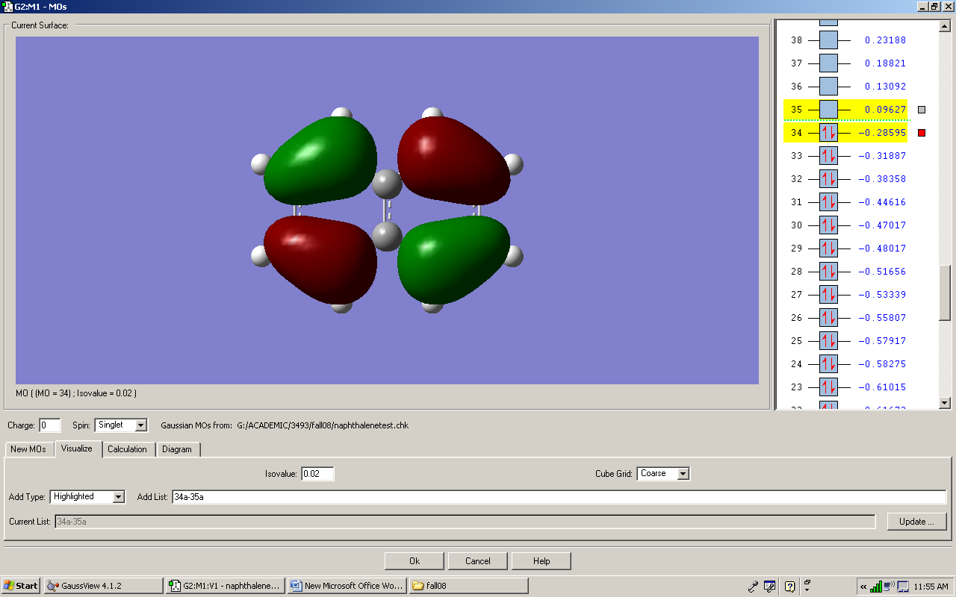

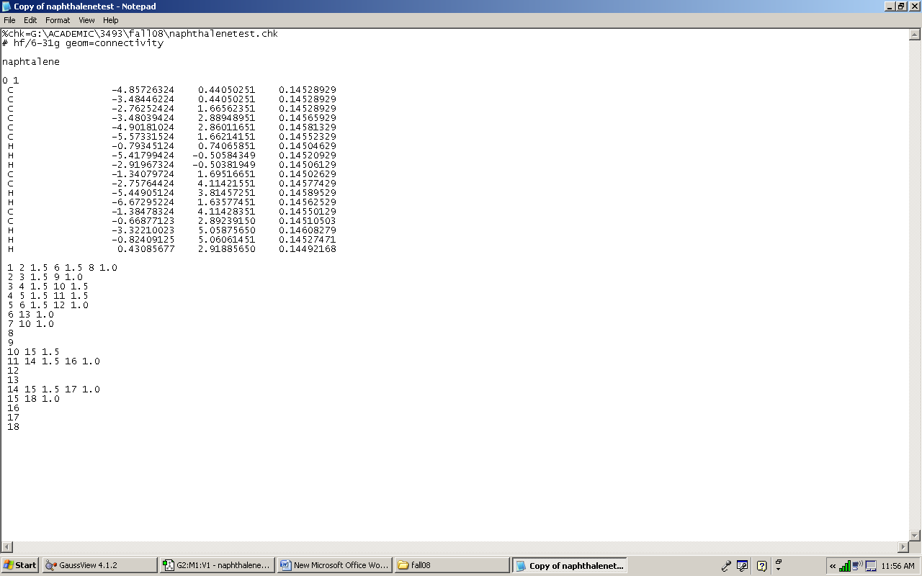

Mulliken atomic charges:

1

1 C -0.211524

2 C -0.169946

3 C -0.068760

4 C -0.068573

5 C -0.169171

6 C -0.211809

7 H 0.212208

8 H 0.203420

9 H 0.212093

10 C -0.169207

11 C -0.170076

12 H 0.212326

13 H 0.203416

14 C -0.211452

15 C -0.211810

16 H 0.211933

17 H 0.203421

18 H 0.203511

Sum of Mulliken charges= 0.00000

SCF Done: E(RHF) = -383.218171083 A.U. after 6 cycles

Convg = 0.1874D-04 -V/T = 2.0000

S\*\*2 = 0.0000