Yes, e= mc^2 is as relevant to a campfire as it is to a fission bomb — at a high level of abstraction, it provides some interesting insights and even provides a (very high) upper limit to how much energy could be extracted from a stick of firewood or a stick of uranium. But in terms of the practical measures needed to build a campfire or bomb, not so much.

**Do you even need to know that E=mc² to make an atomic bomb?** Perhaps surprisingly, you don’t! There are other, more physically intuitive ways to calculate (or measure) the energy release from a fission reaction.

But I think it is not totally crazy to say that even if you somehow imagine a world in which Einstein had never existed, that the physics of an atomic bomb would still work out fine — Einstein’s specific technical work wasn’t central to the problem at all.

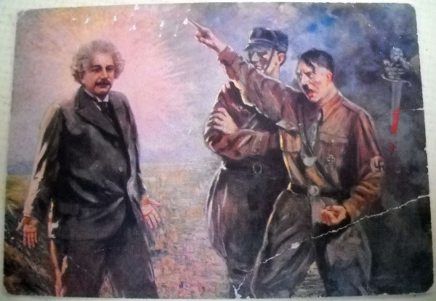

**Einstein wasn’t involved with any of the later work that actually led to the bomb.** He almost was, though: in late 1941, Bush considered consulting Einstein for help on the diffusion problem, but opted not to push for it — both because Einstein wasn’t regarded as politically reliable (he had a [fat FBI file](http://www.amazon.com/gp/product/0312288565/ref=as_li_qf_sp_asin_il_tl?ie=UTF8&camp=1789&creative=9325&creativeASIN=0312288565&linkCode=as2&tag=restrdata-20&linkId=UXAVHFH7YV34PUQB)), and his approach to physics just wasn’t very right for practical problems.[3](http://blog.nuclearsecrecy.com/2014/06/27/bomb-without-einstein/#footnote_2_5010) Bush decided that Einstein would stay out of the loop.

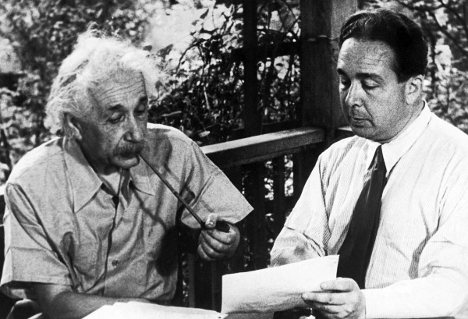

Postwar reconstruction

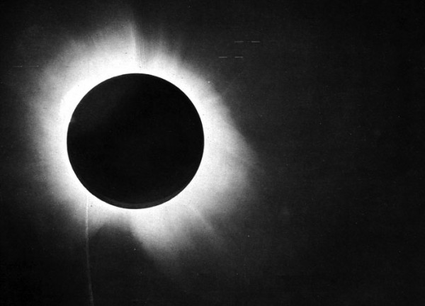

Eddington’s famous plate of the 1919 solar eclipse, which helped confirm Einstein’s theory of General Relativity. Very cool looking, and interesting science. But not relevant to atomic bombs. [Source.](http://en.wikipedia.org/wiki/Solar_eclipse_of_May_29,_1919)

**Moonshine**

[Lawrence's cyclotron](http://www.lbl.gov/Science-Articles/Archive/early-years.html), the Cockroft-Walton machine, and the Van de Graaff electrostatic generator, developed by Robert J. Van de Graaff at Princeton University, were particle accelerators designed to bombard the nuclei of various elements to disintegrate atoms. Attempts of the early 1930s, however, required huge amounts of energy to split atoms because the first accelerators used proton beams and alpha particles as sources of energy. Since protons and alpha particles are positively charged, they met substantial resistance from the positively charged target nucleus when they attempted to penetrate atoms. Even high-speed protons and alpha particles scored direct hits on a nucleus only approximately once in a million tries. Most simply passed by the target nucleus. Not surprisingly, [Ernest Rutherford](http://www.atomicarchive.com/Bios/Rutherford.shtml), [Albert Einstein](http://www.atomicarchive.com/Bios/Einstein.shtml), and [Niels Bohr](http://www.atomicarchive.com/Bios/Bohr.shtml) regarded particle bombardment as useful in furthering knowledge of nuclear physics but believed it unlikely to meet public expectations of harnessing the power of the atom for practical purposes anytime in the near future. In a 1933 interview Rutherford called such expectations "moonshine."5 Einstein compared particle bombardment with shooting in the dark at scarce birds, while Bohr, the Danish Nobel laureate, agreed that the chances of taming atomic energy were remote.6

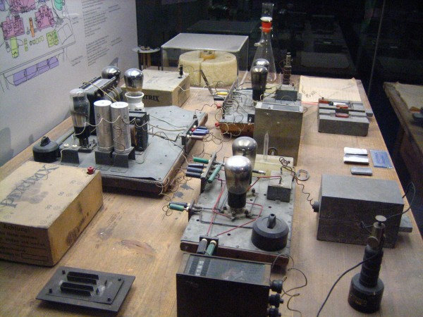

The Hahn-Meitner-Strassman experiment apparatus, at the Deutsches Museum in Munich. My own photo.

As quoted in "Atom Energy Hope is Spiked By Einstein / Efforts at Loosing Vast Force is Called Fruitless," *Pittsburgh Post-Gazette* (29 December 1934); it was only after the breakthroughs by [Enrico Fermi](https://en.wikiquote.org/wiki/Enrico_Fermi) and others in producing nuclear chain reactions that the use of nuclear power became plausible.

**"There is not the slightest indication that [nuclear energy] will ever be obtainable. It would mean that the atom would have to be shattered at will.** [SOURCE: "Atom Energy Hope is Spiked By Einstein / Efforts at Loosing Vast Force is Called Fruitless," Pittsburgh Post-Gazette (29 December 1934)

• Being a lover of freedom, when the revolution came in Germany, I looked to the universities to defend it, knowing that they had always boasted of their devotion to the cause of truth; but, no, the universities immediately were silenced. Then I looked to the great editors of the newspapers whose flaming editorials in days gone by had proclaimed their love of freedom; but they, like the universities, were silenced in a few short weeks. Then I looked to individual writers who, as literary guides of Germany, had written much and often concerning the place of freedom in modern life; but they, too, were mute.

Only the church stood squarely across the path of Hitler's campaign for suppressing truth. I never had any special interest in the church before, but now I feel a great affection and admiration because the church alone has had the courage and persistence to stand for intellectual truth and moral freedom. I am forced thus to confess that what I once despised I now praise unreservedly.

**It is true that I made a statement which corresponds approximately with the text you quoted. I made this statement during the first years of the Nazi-Regime — much earlier than 1940 — and my expressions were a little more moderate.**” (March 1943)

**Eyewitness 1934: He was no Einstein at predictions**

January 24, 2010 12:00 AM

By Len Barcousky Pittsburgh Post-Gazette

When Albert Einstein was quizzed about his theories by Pittsburgh newspaper reporters, he wasn't afraid to admit uncertainty.

A series of five images of the Nobel Prize-winning physicist accompanied one Pittsburgh Post-Gazette story about his 1934 visit to the city for a scientific conference. "These portrait photographs show him first, listening eagerly; next, getting a gleam of insight into the questions; third, explaining slowly and patiently; fourth, making his point clear; and last -- the smile itself.

"He did not hesitate to say, 'I don't know,' frequently in reply to queries by his interviewers," according to the newspaper.

Einstein was in Pittsburgh for a meeting of the American Association for the Advancement of Science.

He remains best known for his theory of relativity -- which concludes, among other things, that time depends on how fast you are moving -- and for the famous formula "E=mc2" (energy equals mass multiplied by the speed of light squared).

During his lecture at Carnegie Tech, now Carnegie Mellon University, Einstein filled chalkboards several times as he offered what he called a new and simplified proof for that equation.

Howard W. Blakeslee, the Associated Press science editor, had the task of interpreting Einstein's Dec. 28 talk for Post-Gazette readers. A native German speaker, Einstein delivered his Carnegie Tech lecture in English. The newspaper said it was the first time he had done a talk in the language of his new homeland.

"He got rid of the complicated electromagnetic fields with which this equivalence of mass [or weight] and energy have heretofore been proven," Blakeslee wrote in a next-day story. "He used instead the simple collision of two material particles to prove the same thing."

The journalist described the talk as "his first important speech in the United States and his first important announcement in several years."

Einstein had left Germany for lectures in America shortly before Adolf Hitler came to power in January 1933. On returning to Europe, he renounced his German citizenship and spent several months in exile in Belgium and Great Britain. He returned to the United States for good in October 1933.

Einstein spoke in the Little Theater at Carnegie Tech, which seated about 400 people and was filled "from back wall to stage."

"Einstein slipped in by the back door and behind the stage curtain began covering two blackboards with figures and mathematical symbols."

"As mathematical symbols, they were unusually simple," Blakeslee wrote. "[O]rdinary letters and numerals, except one which somewhat resembled a snake striking." That was likely the mathematical symbol for an integral.

"The curtain rose with Einstein standing beside the two blackboards, his greying hair standing at all angles, a boyish grin on his face which set the audience of scientists to chuckling," Blakeslee wrote.

Mass-energy equivalence had been an important concept in the early 1930s for investigating atomic nuclei, where, Blakeslee wrote, 99 percent of the mass and 99 percent of an atom's energy were locked away.

After his talk at Carnegie Tech, Einstein agreed to meet with about 20 newspaper reporters at the home of Pittsburgh merchant Nathaniel Spear. He declined to discuss non-scientific topics, and to scientific questions he often answered that "We need more observational data" or "It remains to be proved."

On one topic, he was more assured. "The idea that man might some day utilize the atom's energy brought the only emphatic denial from the noted scientist yesterday," the Post-Gazette reported

Releasing usable energy would require striking the nucleus with other atomic particles, he told reporters. "It's like shooting birds in the dark in a country where there are only a few birds," Einstein said.

As World War II approached, Einstein changed his mind about those odds, and he lobbied President Franklin Roosevelt to launch research into building a nuclear weapon.

On July 16, 1945 -- slightly more than 10 years after Einstein made his Pittsburgh prediction -- he was proved wrong with the successful test of an atomic bomb.

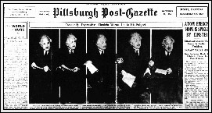

* [Home](https://www.newscientist.com)
* [News](https://www.newscientist.com/section/news/)
* [Physics](https://www.newscientist.com/subject/physics/)
* [Space](https://www.newscientist.com/subject/space/)
* [Technology](https://www.newscientist.com/subject/technology/)

[Daily news](https://www.newscientist.com/article_type/daily-news/)

3 April 2008

**10 impossibilities conquered by science**

What is truly impossible? To accompany **Michio Kaku**‘s [article on the physics of impossibility](https://www.newscientist.com/article/mg19826501-600-impossible-physics-never-say-never), we have rounded up 10 things that were once thought scientifically impossible. Some were disproved centuries ago but others have only recently begun to enter the realm of possibility.

**1. Analysing stars**

In his 1842 book [*The Positive Philosophy*](http://socserv2.mcmaster.ca/%7Eecon/ugcm/3ll3/comte/), the French philosopher Auguste Comte wrote of the stars: “We can never learn their internal constitution, nor, in regard to some of them, how heat is absorbed by their atmosphere.” In a similar vein, he said of the planets: “We can never know anything of their chemical or mineralogical structure; and, much less, that of organized beings living on their surface.”

Comte’s argument was that the stars and planets are so far away as to be beyond the limits of everything but our sense of sight and geometry. He reasoned that, while we could work out their distance, their motion and their mass, nothing more could realistically be discerned. There was certainly no way to chemically analyse them.

Ironically, the discovery that would prove Comte wrong had already been made. In the early 19th century, William Hyde Wollaston and Joseph von Fraunhofer independently discovered that the spectrum of the Sun contained a great many dark lines.

By 1859 these had been shown to be atomic absorption lines. [Each chemical element present in the Sun could be identified](https://www.newscientist.com/article/mg14619725-800-happy-birthday-helium) by analysing this pattern of lines, making it possible to discover just what a star is made of.

**2. Meteorites come from space**

Astronomers look away now. Throughout the Renaissance and the early development of modern science, astronomers refused to accept the existence of meteorites. The idea that stones could fall from space was regarded as superstitious and possibly heretical – surely God would not have created such an untidy universe?

The [French Academy of Sciences](http://www.academie-sciences.fr/actualites/nouvelles_gb.htm) famously stated that “rocks don’t fall from the sky”. Reports of fireballs and stones crashing to the ground were dismissed as hearsay and folklore, and the stones were sometimes explained away as “thunderstones” – the result of lightning strikes.

It was not until 1794 that Ernst Chladni, a physicist known mostly for his work on vibration and acoustics, published a book in which he argued that [meteorites came from outer space](http://www.meteorlab.com/METEORLAB2001dev/metics.htm). Chladni’s work was driven by a “fall of stones” in 1790 at Barbotan, France, witnessed by three hundred people.

Chladni’s book, *On the Origin of the Pallas Iron and Others Similar to it, and on Some Associated Natural Phenomena*, earned him a great deal of ridicule at the time. He was only vindicated in 1803, when Jean-Baptiste Biot analysed another fall of stones at L’Aigle in France, and found conclusive evidence that they had fallen from the sky.

**3. Heavier-than-air flight**

The number of scientists and engineers who confidently stated that heavier-than-air flight was impossible in the run-up to the [Wright brothers’ flight](https://www.newscientist.com/article/mg17823976-100-first-flight-the-wright-brothers-and-the-invention-of-the-airplane-by-t-a-heppenheimer-and-other-books133) is too large to count. Lord Kelvin is probably the best-known. In 1895 he stated that “heavier-than-air flying machines are impossible”, only to be proved definitively wrong just eight years later.

Even when Kelvin made his infamous statement, scientists and engineers were closing rapidly on the goal of [heavier-than-air flight](https://www.newscientist.com/article/mg16622437-900-taking-flight). People had been flying in balloons since the late eighteenth century, and by the late 1800s these were controllable. Several designs, such as Félix du Temple’s *Monoplane*, had also taken to the skies, if only briefly. So why the scepticism about heavier-than-air flight?

The problem was set out in 1716 by the scientist and theologian Emanuel Swedenborg in an article describing a design for a flying machine. Swedenborg wrote: “It seems easier to talk of such a machine than to put it into actuality, for it requires greater force and less weight than exists in a human body.”

Swedenborg’s design, like so many, was based on a flapping-wing mechanism. Two things had to happen before heavier-than-air flight became possible. First, flapping wings had to be ditched and replaced by a gliding mechanism. And secondly, engineers had to be able to call on a better power supply – the internal combustion engine. Ironically, Nicolaus Otto had already patented this in 1877.

**4. Space flight**

From atmospheric flight, to space flight. The idea that we might one day send any object into space, let alone put men into orbit, was long regarded as preposterous.

The scepticism was well-founded, since the correct technologies were simply not available. To travel in space, [a craft must reach escape velocity](https://www.newscientist.com/article/mg19526201-100-space-travel-the-diy-rocketeers-guide) – for vehicles leaving Earth, this is 11.2 kilometres per second. To put this figure into perspective, the sound barrier is a mere 1,238 kilometres per hour, yet it was only broken in 1947.

[Jules Verne](https://www.newscientist.com/article/mg14419544-200-jules-vernes-swing-at-the-sixties) proposed a giant cannon in his novel *From the Earth to the Moon*. However, such a sudden burst of acceleration would inevitably kill any passengers instantly, and calculations have shown no cannon [could be powerful enough](https://www.newscientist.com/article/mg18224525-100-firing-at-the-moon) to achieve escape velocity.

The problem was effectively cracked in the early 20th century by two rocket researchers working independently – [Konstantin Tsiolkovsky](https://www.newscientist.com/article/mg17123025-400-cosmic-comrades) and Robert Goddard. Tsiolkovsky’s work was ignored outside the USSR, while Goddard withdrew from the public gaze after scathing criticism of his ideas. Nonetheless, the [first artificial satellite](https://www.newscientist.com/article/dn12599-introduction-sputniks-legacy), Sputnik, was eventually launched in 1957, and the first manned spaceflight followed four years later. Neither Tsiolkovsky nor Goddard lived to see it.

**5. Harnessing nuclear energy**

On 29 December 1934, Albert Einstein was quoted in the *Pittsburgh Post-Gazette* as saying, “There is not the slightest indication that [nuclear energy] will ever be obtainable. It would mean that the atom would have to be shattered at will.” This followed the discovery that year by Enrico Fermi that if you [bombard uranium with neutrons](https://www.newscientist.com/article/mg13618494-000-the-day-chicago-went-critical), the uranium atoms split up into lighter elements, releasing energy.

Einstein’s scepticism was, however, overtaken by events. By 1939, nuclear fission was better understood and researchers had realised that a chain reaction – one that, once started, would drive itself at increasing rates – could produce a huge explosion. In late 1942, such a chain reaction was produced experimentally, and on August 6 1945 the first atomic bomb used aggressively exploded over Hiroshima. Ironically, [Fleet Admiral William Leahy](http://www.williamdleahy.com/) allegedly told President Truman: “This is the biggest fool thing we’ve ever done – the bomb will never go off – and I speak as an expert on explosives.”

Then, in 1954, the USSR became the first country to supply some of its electricity from nuclear power with its Obninsk nuclear power plant.

**6. Warm superconductors**

This is a strange case: a phenomenon can be observed and measured, but should not be happening. According to the best theories of superconductivity, the phenomenon of superconductivity [should not be possible](https://www.newscientist.com/article/mg15420804-100) above 30 kelvin. And yet some superconductors work perfectly well at 77 K.

Superconductors – materials that conduct electricity with no resistance – were first discovered in 1911. To see the effect, a material normally has to be cooled to within a few degrees of absolute zero.

Over the next 50 years, many superconducting materials were discovered and studied, and in 1957 a complete theory describing them was put forward by John Bardeen, Leon Cooper and John Schrieffer. Known as “BCS theory”, it neatly explained the behaviour of standard superconductors.

The theory states that electrons within such materials move in so-called Cooper pairs. If a pair is held together strongly enough, it can withstand any impacts from the atoms of the material, and thus experiences zero electrical resistance. However, the theory suggested that this should only be true at extremely low temperatures, when the atoms only vibrate slightly.

Then, in a [classic paper](http://dx.doi.org/10.1007/BF01303701) published in 1986, Johannes Georg Bednorz and Karl Alexander Müller turned the field upside-down, discovering a material capable of superconducting at up to 35 K. Bednorz and Müller received the Nobel Prize for Physics the following year and more high-temperature superconductors followed. The [highest cutoff temperature yet observed](http://dx.doi.org/10.1103/PhysRevB.50.4260) (admittedly under pressure) is 164 K. Yet, quite how this is all possible remains a topic of intense research.

**7. Black holes**

People who think of black holes as a futuristic or modern idea may be surprised to learn that the basic concept was first mooted in 1783, in a [letter to the Royal Society](http://dx.doi.org/10.1098/rstl.1784.0008) penned by the geologist John Michell. He argued that if a star were massive enough, “a body falling from an infinite height towards it would have acquired at its surface greater velocity than that of light… all light emitted from such a body would be made to return towards it by its own proper gravity.”

However, throughout the 19th century the idea was rejected as outright ridiculous. This was because physicists thought of light as a wave in [the ether](https://www.newscientist.com/article/mg18624930-900-catching-the-cosmic-wind) – it was assumed to have no mass, and therefore to be immune to gravity.

It was not until Einstein published his [theory of general relativity](http://en.wikipedia.org/wiki/General_relativity) in 1915 that this view had to be seriously revised. One of the key predictions of Einstein’s theory was that light rays would indeed be deflected by gravity. Arthur Eddington’s [measurements of star positions](https://www.newscientist.com/article/mg13918853-000-science-a-down-to-earth-test-for-general-relativity) during a solar eclipse showed that their light rays were deflected by the Sun’s gravity – though actually [the effect was too small](https://www.newscientist.com/article/mg16321935-300-ode-to-albert) for Eddington’s instruments to reliably observe, and it was not properly confirmed until later on.

But, once relativity was established, black holes became a serious proposition and their properties were worked out in detail by theoreticians such as [Subrahmanyan Chandrasekhar](https://www.newscientist.com/article/mg15721225-800-review-a-giant-among-the-dwarfs). Astronomers then began searching for them, and accumulated evidence that [black holes are common](https://www.newscientist.com/article/mg13618414-900-black-holes-reveal-themselves) with one at the [centre of many galaxies](https://www.newscientist.com/article/mg15320653-000-science-a-black-hole-may-lurk-at-the-heart-of-every-galaxy) ([including our own](https://www.newscientist.com/article/dn2936-milky-ways-giant-black-hole-pinned-down)) and the biggest ones being [responsible for high-energy cosmic rays](https://www.newscientist.com/article/dn12897-monster-black-holes-power-highest-energy-cosmic-rays).

Perhaps the debate has not been entirely settled, though. Some controversial calculations, published in 2007, suggested that as stars collapsed into black holes, they would release a great deal of radiation, reducing their mass so that they [do not form “true” black holes](https://www.newscientist.com/article/dn12089-do-black-holes-really-exist) after all.

**8. Creating force fields**

This classic of science fiction went from wild speculation to verifiable fact in 1995 with the invention of the “[plasma window](https://www.newscientist.com/article/mg17823904-800-hot-mettle)“.

Devised by Ady Hershcovitch from the Brookhaven National Laboratory, the plasma window uses a magnetic field to fill a small region of space with plasma or ionised gas. The devices, developed by Hershcovitch and the company Acceleron, are used to reduce the energy demands of electron beam welding.

The plasma window has most of the properties we associate with force fields. It blocks matter well enough to act as a barrier between a vacuum and the atmosphere. It also allows lasers and electron beams to pass through unimpeded and will even glow blue, if you make the plasma out of argon.

The only drawback is that it requires huge amounts of energy to produce plasma windows of any size, so current examples are very small. In theory, though, there is no reason they could not be made much bigger.

**9. Invisibility**

Invisibility is another staple of fantasy fiction, appearing in everything from Richard Wagner’s opera *Das Rheingold* to H. G. Wells’ *The Invisible Man*, and of course *Harry Potter*.

There is nothing in the laws of physics to say invisibility is impossible, and recent advances mean certain types of cloaking device are already feasible.

The last few years have seen a rash of reports concerning [experimental invisibility cloaks](https://www.newscientist.com/article/mg19325911-900-invisibility-cloaks-now-you-see-them133), ever since a [basic design](https://www.newscientist.com/article/dn9227-physicists-draw-up-plans-for-real-cloaking-device) for one was produced in 2006. These devices rely on [metamaterials](http://en.wikipedia.org/wiki/Metamaterial) to guide light around objects. The first of these only worked on [microscopic objects](https://www.newscientist.com/article/dn10334-working-invisibility-cloak-created-at-last) and with microwaves.

It was thought that modifying the design for visible light would prove very challenging, but in fact [it was done just one year later](https://www.newscientist.com/article/dn12722-gold-rings-create-first-true-invisibility-cloak) – albeit only in two dimensions and on a micrometre scale. The engineering challenges involved with building a practical invisibility cloak remain formidable.

**10. Teleportation**

This is a word with a long and rather dubious history. It was coined by the paranormalist writer Charles Fort in [his book *Lo!*](http://www.resologist.net/lo102.htm) and was subsequently seized on by legions of science fiction writers; most famously as the “transporter” in *Star Trek*.

Despite its fantastical origins, physicists have [achieved a kind of teleportation](https://www.newscientist.com/article/dn1346-entangled-clouds-raise-hope-of-teleportation) thanks to a bizarre quantum phenomenon called [entanglement](https://www.newscientist.com/article/mg18124404-700-the-weirdest-link). Particles that are entangled behave as if they are linked together no matter how wide the distance between them. If, for example, you change the “spin” of one entangled electron, the spin of its twin will change as well.

Entangled particles can therefore be used to [“teleport” information](https://www.newscientist.com/article/dn10226-spooky-steps-to-a-quantum-network). Performing the trick with anything larger than an atom was once thought impossible, but in 2002 a theoretical way to [entangle even large molecules](https://www.newscientist.com/article/dn1888-teleporting-larger-objects-becomes-real-possibility), providing they can be split into a quantum state known as superposition, was described.

More recently, an alternative idea, dubbed [“classical teleportation”](https://www.newscientist.com/article/mg19426085-800-teleportation-but-not-as-we-know-it), was proposed for making a beam of rubidium atoms effectively disappear in one place and reappear elsewhere. This method would not rely on entanglement, but transmitting all the information about these atoms through a fibre optic cable so that they can be “reconstructed” somewhere else.

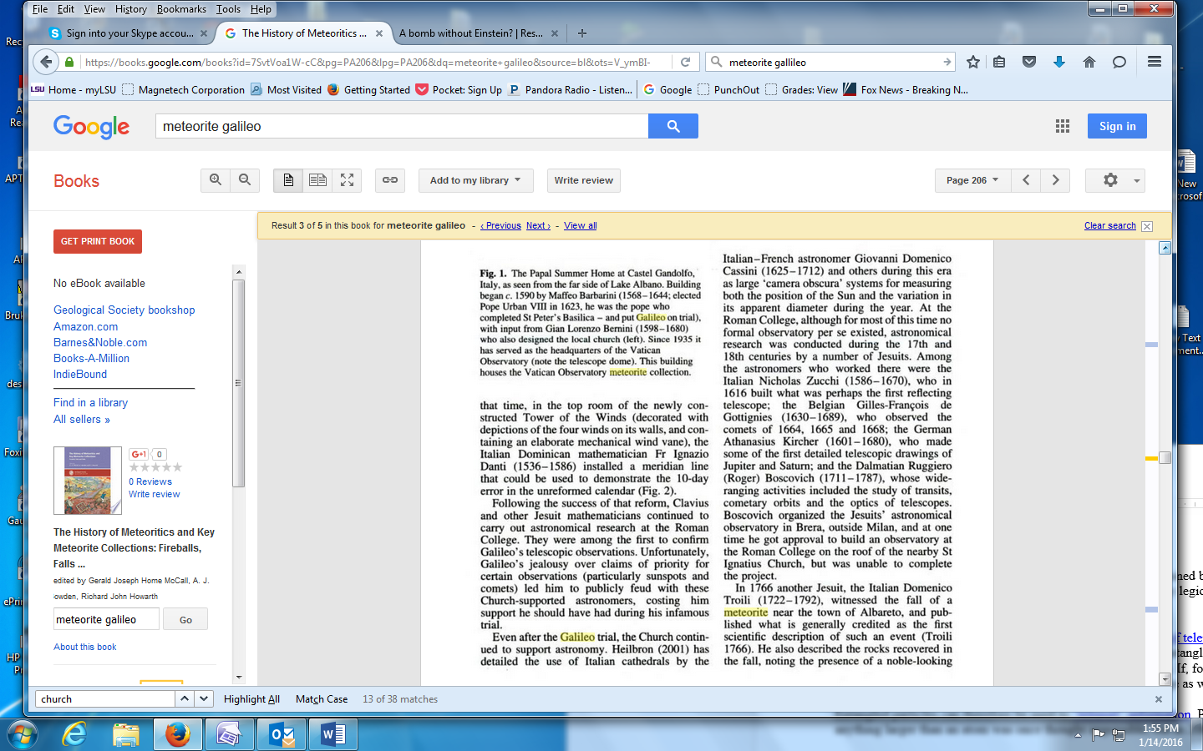

## Grassi on the comets

The immediate context of the book was a polemic against the treatise on the [comets](https://en.wikipedia.org/wiki/Comet) of 1618 by [Orazio Grassi](https://en.wikipedia.org/wiki/Orazio_Grassi), a [Jesuit](https://en.wikipedia.org/wiki/Jesuit) mathematician at the [Collegio Romano](https://en.wikipedia.org/wiki/Collegio_Romano). In this matter Grassi, for all his [Aristotelianism](https://en.wikipedia.org/wiki/Aristotelianism), was right and Galileo was wrong. Galileo incorrectly treated the comets as a play of light rather than as real objects.

The other aspect of all this which has been hotly debated is: what constitutes proof or demonstration of a scientific claim? In 1616, the same year that Copernicus' book was placed on the Index of Prohibited Books, Galileo was called before Cardinal Robert Bellarmine, head of the Holy Office of the Inquisition and warned not to defend or teach Copernicanism. During this year Galileo also completed a manuscript, *On the Ebb and Flow of the Tides*. The argument of this manuscript will turn up 17 years later as day Four of Galileo's *Dialogues concerning the Two Chief World Systems*. This argument, about the tides, Galileo believed provided proof of the truth of the Copernican theory. But insofar as it possibly does, it provides an argument for the physical plausibility of Galileo's Copernican theory. Let's look more closely at his argument.

Galileo argues that the motion of the earth (diurnal and axial) is the only conceivable (or maybe plausible) physical cause for the reciprocal regular motion of the tides. He restricts the possible class of causes to mechanical motions, and so rules out Kepler's attribution of the moon as a cause. How could the moon without any connection to the seas cause the tides to ebb and flow? Such an explanation would be the invocation of magic or occult powers. So the motion of the earth causes the waters in the basins of the seas to slosh back and forth, and since the earth's diurnal and axial rotation is regular, so are the periods of the tides; the backward movement is due to the residual impetus built up in the water during its slosh. Differences in tidal flows are due to the differences in the physical conformations of the basins in which they flow (for background and more detail, see Palmieri 1998).

Albeit mistaken, Galileo's commitment to mechanically intelligible causation makes this is a plausible argument. One can see why Galileo thinks he has some sort of proof for the motion of the earth, and therefore for Copernicanism. Yet one can also see why Bellarmine and the instrumentalists would not be impressed. First, they do not accept Galileo's restriction of possible causes to mechanically intelligible causes. Second, the tidal argument does not directly deal with the annual motion of the earth about the sun. And third, the argument does not touch anything about the central position of the sun or about the periods of the planets as calculated by Copernicus. So at its best, Galileo's argument is an inference to the best partial explanation of one point in Copernicus' theory. Yet when this argument is added to the earlier telescopic observations that show the improbabilities of the older celestial picture, to the fact that Venus has phases like the moon and so must revolve around the sun, to the principle of the relativity of perceived motion which neutralizes the physical motion arguments against a moving earth, it was enough for Galileo to believe that he had the necessary proof to convince the Copernican doubters. Unfortunately, it was not until after Galileo's death and the acceptance of a unified material cosmology, utilizing the presuppositions about matter and motion that were published in the *Discourses on the Two New Sciences,* that people were ready for such proofs. But this could occur only after Galileo had changed the acceptable parameters for gaining knowledge and theorizing about the world.

To read many of the documents of Galileo's trial see Finocchiaro 1989, and Mayer 2012. To understand the long, tortuous, and fascinating aftermath of the Galileo affair see Finocchiaro 2005, and for John Paul II's attempt see George Coyne's article in McMullin 2005.